

**WarShall’s algorithM**

**[Area: Graph path]**



**Group members:**

**Ayesha Naz CT-53**

**Yashfa Azeem CT-54**

**Namra Muneer CT-59**

**Ruhma Alavi CT-64**

**Introduction:**

Algorithms are a very useful, step-by-step method, defined by a set of instructions to be executed in a sequential manner to achieve the desired result or output for a specified task. Algorithms are generally paired with words that highlight the specific area the algorithm is designed for. A search algorithm, for example, is a procedure used to determine what kind of information is retrieved from a large mass of data. Moreover, an encryption algorithm is a set of rules by which information or messages are encoded so that unauthorized persons cannot read them. Algorithms are really important because they help software developers create efficient and error free programs.

The area that we are working on for our project is Graph Path and the algorithm is Warshall Algorithm.

Warshall's algorithm is used to determine the transitive closure of a directed graph or all paths in a directed graph by using the adjacency matrix. The matrix formed is of Boolean type. For this, it generates a sequence of n matrices. Where, n is used to describe the number of vertices. Warshall algorithm is used to find path problem from a given directed graph. As a result of this algorithm, it will generate a matrix, which will represent the minimum distance from any node to all other nodes in the graph.

**Algorithm :**

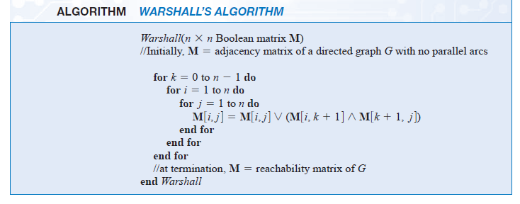

## **How Warshall Algorithm Works**

### R =

### R(p)

### R(q)

### R(s) $\left.\left[\begin{matrix}0 & 0 & 0 & 1 \\ 1 & 0 & 1 & 1 \\ 1 & 0 & 0 & 1 \\ 1 & 0 & 1 & 1\end{matrix}\right.\right]$

### R(w) $\left.\left[\begin{matrix}1 & 0 & 1 & 1 \\ 1 & 0 & 1 & 1 \\ 1 & 0 & 1 & 1 \\ 1 & 0 & 1 & 1\end{matrix}\right.\right]$

### Implementation:

### 

### 

### Output:

### 

### Time Complexity:

There are three loops for computing the shortest path in the graph and each of these loops has constant complexities. Therefore, due to this, the time complexity of the Warshall algorithm is O(n3).

Space Complexity:

In the Space efficiency of this algorithm, the matrices can be written over their predecessors.Θ(n3) is the worst-case cost. We should know that the brute force algorithm is better than Warshall's algorithm. In fact, the brute force algorithm is also faster for a space graph.

### Applications of Warshall Algorithm:

* It helps to find the shortest path in a directed graph.
* Different versions of the Warshall algorithm help to find the transitive closure of a directed graph.
* This algorithm helps to find the regular expression that are accepted by finite automata.
* It helps in finding the similarity between the graphs.
* Warshall algorithm helps in finding the optimal routing i.e the maximum flow between two vertices.